2021-2022 SSFM Core Goals, Values and Concepts
Core Values: 1) Valuing people and where they are in their spiritual journey. 2) Agility, flexibility and resilience during this time of challenge and change. 3) Focus on success in developing an Anglican/Episcopal Ethos and Innovation in use of online learning/cohort formation/onsite opportunities. 4) Delivering Value and excellence in results to the communities we serve.
PURPOSE of Goals:
- Continued systematic development of and evaluation of formation through SSFM. Includes:
  - Course content, presentations, teaching strategies of faculty evaluations of vocational courses
  - Integration and evaluation of Becoming the Beloved Community through all courses
  - Integration and evaluation spiritual needs of the students and faculty during this time of COVID-19 –soul tending to offer resources such as Gina Campbell January 8th
  - Student recruitment continuing with minimum of students needed for each course to run in relationship to scope and sequence; we need to sustain a cohort of 10 for each year of vocational courses
  - Invitation for other diocese to participate with their students, clergy and congregations and at a deeper level supporting SSFM.
Strategic Execution of The Stevenson School for Ministry Goals
- Vocational formation—Goal: to offer affordable, flexible, adaptable formation to prepare for ordered ministry and lay canonical areas of ministry 1) Curriculum evaluation for vocational formation; lay and ordained. 2) Making necessary changes to deepen intersectionality and integration of course content across courses. 3) Creating faculty teams through quarterly conversations with faculty
- The Collaborative Mission Center---Goals for 2021-2022: Director, Deacon Marsha Roscoe 1) to provide training and formation in racial justice 2) to provide training and formation in House Church/Small group formation 3) to provide training in parish life that support the Shaped by Faith diocesan initiative through on-line asynchronistic and synchronistic education and mentoring through 3- 5 -week online modules offered for training, teaching, spiritual formation, and Shaped by Faith coaching. (51 participants fall term, 93 participants in winter Term)
- Anglican Studies Joint Certificate Goals 2021-2022 Curriculum team led by David Zwifka 1) to collaborate with Lancaster Theological Seminary for student recruitment. 2) To offer to LTS our racial justice modules/webinars to promote to students and faculty 3) to offer to Moravian Seminar our racial justice modules/webinars 4) To stay at the table during the transition of LTS into Moravian Seminary
- Continuing Education Goals 1) To develop a promotional effort for Continuing education for clergy; includes collaborating Diocese and marketing info to them, VTS, LTS, and Moravian. 2) To develop a promotional effort for continuing education for laity, includes congregational leadership, parishioners and students who have engaged in our lectionary series.
- Director of Spiritual Formation and integrative formation , David Zwifka is leading us into a time of integration of spiritual with the academic. Purpose: The Spiritual Formation Director of SSFM is immediately responsible for the planning, implementation, and periodic evaluation of spiritual formation programming within the SSFM community, is accountable to the Dean of SSFM and, through the dean, its client dioceses should be in consultation with all members of the academic faculty, and internship/field placement supervisors.
  - Develop a Spiritual Life Committee that can provide a forum for faculty and students to come together to reflect and offer consultation on issues of spiritual formation
  - Develop integrative seminar two per term.
  - Group Spirituality and Retreat development for SSFM participants--Periods of more intensive spiritual formation
- Podcasts for the Public goals 1) To collaborate on topics with the Lower Susquehanna Synod 2) To follow up webinar events with a podcast from the speakers, leadership and attenders.
Program and Partnerships
- Support the new Dean, Associate Dean and SSFM CMC director, Marsha Roscoe, in the Development of Parish Life Courses in the Collaborative Mission Center and beta testing some of the courses, determining the possibility for asynchronistic learning and discerning the spiritual need. In partnership with the Lower Susquehanna Synod.
  - Phase 1 (2021 fall term)—Develop a scope and sequence of all parish life courses available for Shaped By Faith formation with Canon Chris Streeter and continuing education for 2021-2022.
  - Phase 1.5 (2021-2022) the redevelopment of the COLLABORATIVE MISSION CENTER with the Lower Susquehanna Synod to offer specific certificate courses.
    - Marsha Roscoe director—Bishop’s staff LSS
    - Racial Justice Missioner -modules/courses and webinars shared with LSS -The Rev. Carla Christopher Wilson Fall 2021 , a certificate for Racial Justice Missioner
    - Shared webinar/and liturgical season formation series.
  - Phase 2 (2021-2022) relationship building of SSFM and formation modules with congregations while integration with the models and congregational initiatives through “Shaped by Faith”
- 2022 June, re-evaluate the joint certificate Stevenson School for Ministry with Lancaster Theological Seminary as it is in transition with Moravian Seminary for 2022-2023 academic year.
- Podcast development support formation in racial justice, evangelism, and continuing education in Scripture and Prayer Book promoting Biblical literacy

Finance—immediate work; Determining the best way to apply available resources
- Comparative analysis end of year 2021 to new year 2022 and completing the 2021-2022 Academic year for charting growth
- Grant writing—Schedule for 2022 completed by December 2021
- Development work with financial stakeholders
Intergenerational faith formation work 2021-2022
- SSFM offers modules in youth ministry for parish life, family life formation and intergenerational ministry that reflects a virtual and onsite approach to faith formation.
- Diocesan Convention Children’s program and youth program need a development team, formation through the use of asynchronistic modules from SSFM.
- Sharing intergenerational Mission trips throughout the diocese—need a lead person to coordinate if formation will happen through SSFM.
- Resource development and web page for spirituality and formation in the household.
- Teaching Ministry Course development part I and part II for life long comprehensive integrative formation with specifics for children’s ministry, youth ministry.
Advisory Board Specific Goals for SSFM:
  - To continuously become beloved community amongst advisory board members. To live out with each other the way we are forming and integrating spiritual formation with all collaborative relationships; students/faculty/Diocese and staff.
  - To support the new Dean, interim Associate Dean in the transitions of leadership.
  - To continue to develop goals for spiritual formation/marketing/finance for 2022 and 2023. To work with Rob Box, SSFM Treasurer for statistical analysis of finance and growth toward the goals of covering all program costs and Associate Dean salary in 2025.
  - Curriculum Team chaired by David Zwifka and member Shawn Strout along with the new Dean and Associate Dean engage with Dean Heather ( Moravian) and Associate Dean Vanessa (LTS) in the transition with LTS and Moravian Seminary
  - Continue to evaluate and assess the outcomes of SSFM with the vision of SSFM for both lay and ordered ministry.
  - To collaborate with the Commission on ministry in regard to the canonical lay formation certificate program.
  - To continue to offer updates and reports to Lower Susquehanna Synod and the Collaborative Mission Center.
Marketing and Student recruitment
- Marketing team along with the new Dean and Associate Dean evaluate the impact of:
  - Bimonthly news notes
  - Bulletin insert
  - Diocesan web page banner
  - Social media
  - Dean visitations and promotion of SSFM
- Work with Canon Alexis Guszick and Assistant Faith Neice for analytics and branding
- Learn LTS and Discovery Day promotion support for SSFM student recruitment
- Alumni page design for student recruitment.
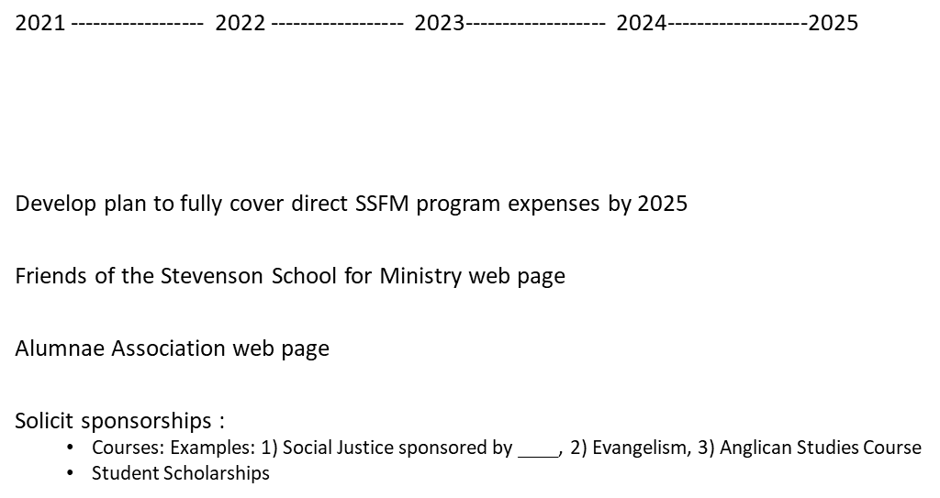
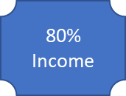
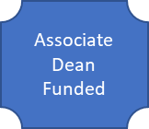
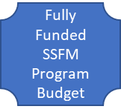
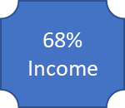
Financial Growth Goals and Sharing our Story
