CUSTOMARIES FOR
EPISCOPAL VISITATIONS AND CONFIRMATIONS
IN THE DIOCESE OF CENTRAL PENNSYLVANIA

The Rt. Rev. Audrey C. Scanlan, XI Bishop

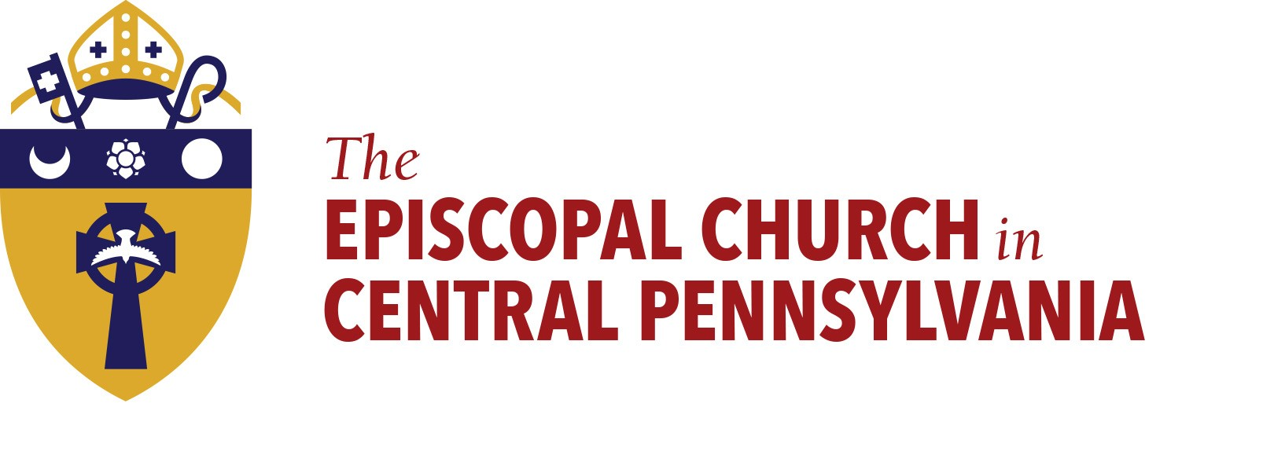
EPISCOPAL VISITATIONS in the DIOCESE OF CENTRAL PENNSYLVANIA

Visitations to parishes will be scheduled on a 2-year rotational cycle. The schedule will be published every 2 years. The list will be posted and kept updated on the diocesan website: www.diocesecpa.org

PLANNING THE VISITATION:

The attached worksheet (Visitation Worksheet) should be submitted to the Bishop’s office no less than 1 month in advance of the visit. This worksheet will offer a proposed list of activities for the visitation period. The Bishop will review the worksheet and a meeting with the clergy person in charge - in person, if possible - to discuss the life of the parish and the ministry of the clergy person will be scheduled to take place in the weeks before the visit. Please call a month in advance (when the worksheet is submitted) to schedule that meeting.

Ideally, the visitation will primarily surround worship on Sunday. If there are 2 services on a Sunday (8:00 and 10:00, eg.) the bishop will preach and preside at both services or, alternatively, a single combined service can be arranged. If the parish generally holds a service on Saturday evening, and the Bishop’s calendar allows, she will be happy to participate in that as well.

If the visitation site is more than 2 hours from Harrisburg the Bishop will arrange for her own local accommodations at cost to the Bishop’s Ministry Expenses budget, not the individual parish.

During the visitation, the clergy person in charge will present the parish registers to the Bishop for her review.

The Bishop would like to have time set aside during the coffee hour/reception after the service for questions and answers with the congregation and an opportunity to greet parishioners individually.

Part of the visitation must include meeting with the Clergy, wardens and vestry. Many parishes find that a meeting following the Sunday service and reception is ideal.

Visitations will conclude by 2 PM on Sunday afternoons in order for the Bishop to secure her Sabbath and family time.

THE SERVICE:

Confirmations and receptions will be a part of visitations in each parish with advance notice and following the protocol and guidelines for confirmation and reception in our diocese. The Customary for Confirmations is attached with this document and is available on the Diocesan website. Please consult with the Clergy Convenor of your Convocation about the option to host a regional confirmation on dates that have already been specified in the calendar.

In the absence of confirmations and receptions, a renewal of baptismal vows will take place at the time of the episcopal visitation. Baptisms are recommended to take place on Feast days. If a baptism is scheduled with the Bishop is present, she will share the administration of the sacrament with the resident clergy-person.

Unless planned otherwise, the Bishop will preach and preside at all services during a visitation.

Bishop Scanlan will preside over a said or sung/chanted Eucharist, as is the parish custom.

The Bishop will wear the parish stole and chasuble (in the appropriate seasonal color) for services.

Altar and hangings are to be in the color of the season, or white or red for confirmation/baptism.

The loose plate offering on the day of the episcopal visitation will be for the Bishop’s Discretionary Fund and submitted by cheque to: Bishop’s Discretionary Fund, The Episcopal Diocese of Central PA 101 Pine St. Harrisburg, PA 17101. Please announce this custom at the time of the announcements or in the bulletin.
Confirmation Customary
The Rt. Rev. Audrey C. Scanlan
(Updated June 2019)

Preparation of Candidates
Candidates will be well prepared for their Confirmation/Reception/Reaffirmation with a working understanding of the sweep of the salvation story; an overview of the history, theology and ecclesiology of the Anglican tradition; and an appreciation of the resources for on-going spiritual formation as disciples of Jesus Christ and participants in God’s Mission. For support in selecting a curriculum, Dean Sarah Stonesifer Boylan, sboyan@diocesecpa.org, at the Stevenson School for Ministry.

Preparation for Confirmation/Reception/Reaffirmation is understood to be an active process that includes participation by the candidate, the parish Rector (or designated Catechist) and the family and/or support system of the candidate.

All forms of preparation will follow Safe Church procedures.

Candidates must be able to demonstrate a willingness to pursue discipleship in Jesus Christ and membership in God’s Holy Church.

Candidates may be of any age, keeping in mind that Confirmation is the liturgical event by which one makes a “mature affirmation of faith.”

Administrative Procedure

Four (4) weeks in advance, the Confirmation/Reception/Reaffirmation form will be completed listing the names, dates of baptism, etc. of the candidates and sent to Nichol Free, nfree@diocesecpa.org, Executive Assistant to the Bishop in order to return the appropriate number of certificates. A Microsoft Word fillable form will be emailed to you and is also available on the diocesan website. If you do not have access to Microsoft Word, a form that can be printed and filled in can be emailed to you.

The Confirmations/Receptions/Reaffirmations will be duly recorded in the parish register of the church.

In the event that the parish wishes to bring their candidates to another parish visitation, contact the bishop’s Executive Assistant Nichol Free, nfree@diocesecpa.org, in the Bishop’s office and a courtesy call to the hosting parish at least four (4) weeks in advance is required.

No other bishop other than the Bishop Diocesan may perform Confirmations/Receptions/ Reaffirmations in the parishes of the Diocese of Central Pennsylvania without advance permission from the Bishop’s office. If a service of Confirmation is desired outside of your regular visitation, please consult with the Clergy Convenor of your Convocation to discuss scheduled regional confirmations.

Before the Service

A meeting of the Candidates and the Bishop in advance of the service is requested in order to review the liturgy and make each other’s acquaintance.

If there are gift books to be signed by the Bishop, they will be presented before the service or at the reception.

The Liturgy

- The Bishop is the customary Officiant, Preacher and Celebrant at services of Confirmation/Reception/Reaffirmation unless decided otherwise in consultation with the Bishop.
- BCP pg. 322: “It is appropriate that the other priests present stand with the celebrant at the Altar, and join in the consecration of the gifts. . . . ” Thus, priests should be vested and, at the Great Thanksgiving, join the bishop at the altar.
- The Paschal candle will be lighted and displayed in a prominent place.
- The Bishop’s Chair- or another suitable chair- will be placed in front of the altar (or in the logical place for the Confirmation/Reception/Reaffirmation to take place) and will be removed after the Confirmation/Reception/Reaffirmation, just before the Offertory.
- The service including Confirmation will begin on page 413 of the BCP.
- Following the sermon, the candidates will be presented, examined and prayed for. Depending on the number of candidates, they may be asked to come forward for the Presentation and Examination or asked to stay in their pews. They should be rehearsed in their responses in the liturgy (BCP pg. 415)
- Prayers for the Candidate are found on BCP pg. 305-6. Please appoint an intercessor to do these.
- Candidates will come forward at the appropriate time and carry an index card with their name printed on it. They may also be invited to say their name out loud for the Bishop.
- The customary posture for Confirmation is kneeling and for Reception and Reaffirmation, standing. If candidates have difficulty kneeling, standing is an acceptable choice.
- Candidates may have family members/mentors assist in laying on of hands if that is the custom of the parish.
- It is the Bishop’s preference that a generous amount of silence take place before praying each person’s prayer of Confirmation/Reception/Reaffirmation.
- The Prayers of the People, Confession and Nicene Creed are omitted in this service.
- Those who are being Confirmed/Received/Reaffirmed may serve as lectors and/or oblation bearers at the discretion of the priest.
- The Proper Preface for Baptism is to be used Confirmations/Receptions/Reaffirmations.

Photography
- Photos taken during the liturgy must be without flash and unobtrusive.
- Photos (if desired) with Confirmands/those Received/Reaffirmed will take place directly after the service in the sanctuary.

