OUT OF THE DEPTHS
A Liturgy of Remembrance for those we love
who died from COVID-19

PRELUDE MUSIC

WORDS OF WELCOME The Rt. Rev. Audrey Scanlan, Bishop
The Episcopal Diocese of Central Pennsylvania

OPENING SENTENCES
Bishop Scanlan: God is our hope and strength,
a very present help in trouble.
People: Therefore we will not fear,
though the earth be moved,
and though the hills be carried
into the midst of the sea. (Psalm 46)

SCRIPTURE READING Isaiah 61:1-4
Kevin Barron: A reading from Isaiah.

The spirit of the Lord God is upon me, because the Lord has anointed me;
he has sent me to bring good news to the oppressed,
to bind up the brokenhearted,
to proclaim liberty to the captives, and release to the prisoners;
² to proclaim the year of the Lord’s favor,
and the day of vengeance of our God;
to comfort all who mourn;
³ to provide for those who mourn in Zion –
to give them a garland instead of ashes,
the oil of gladness instead of mourning,
the mantle of praise instead of a faint spirit.
They will be called oaks of righteousness,
the planting of the Lord, to display his glory.
⁴ They shall build up the ancient ruins,
they shall raise up the former devastations;
they shall repair the ruined cities,
the devastations of many generations.
RESPONSE
Kevin: I lift up my eyes to the hills,
from where will my help come?
People: My help comes from the Lord,
who made heaven and earth. (Psalm 121)

SCRIPTURE READING Revelation 7:9-17
Emma DiPace: A reading from Revelation.

After this I looked, and there was a great multitude that no one could count, from every nation, from all tribes and peoples and languages, standing before the throne and before the Lamb, robed in white, with palm branches in their hands. They cried out in a loud voice, saying, “Salvation belongs to our God who is seated on the throne, and to the Lamb!” And all the angels stood around the throne and around the elders and the four living creatures, and they fell on their faces before the throne and worshiped God, singing, “Amen! Blessing and glory and wisdom and Thanksgiving and honor and power and might be to our God forever and ever! Amen.” Then one of the elders addressed me, saying, “Who are these, robed in white, and where have they come from?” I said to him, “Sir, you are the one that knows.” Then he said to me, “These are they who have come out of the great ordeal; they have washed their robes and made them white in the blood of the Lamb. For this reason they are before the throne of God, and worship him day and night within his temple, and the one who is seated on the throne will shelter them. They will hunger no more, and thirst no more; the sun will not strike them, nor any scorching heat; for the Lamb at the center of the throne will be their shepherd, and he will guide them to springs of the water of life, and God will wipe away every tear from their eyes.”

RESPONSE
Emma: The steadfast love of the Lord never ceases,
his mercies never come to an end.
People: For God does not willingly
afflict or grieve anyone. (Lamentations 3:22, 33)

HYMN I Want to Walk as a Child of the Light
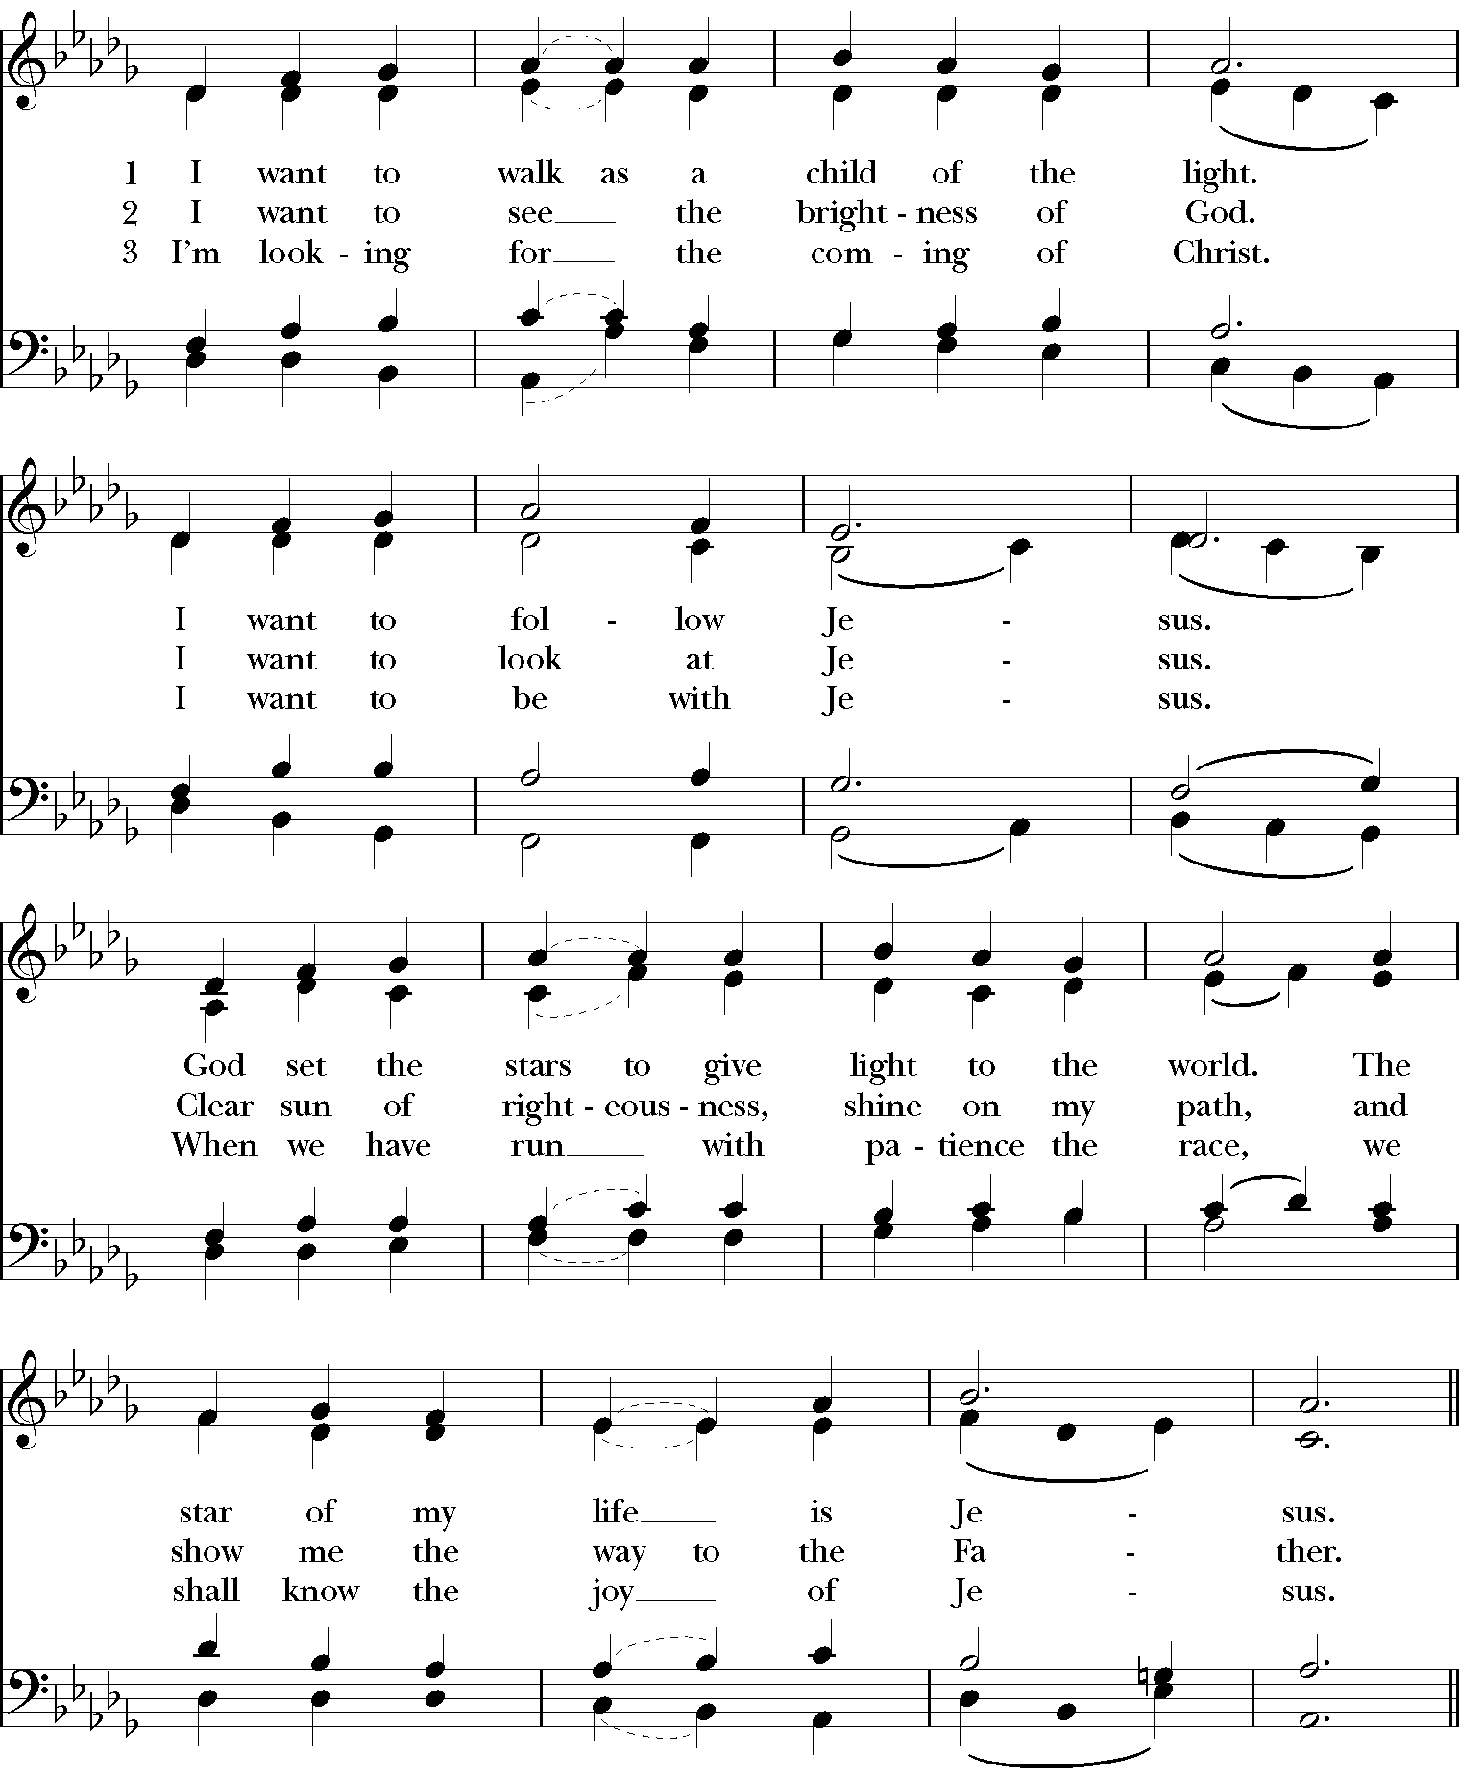

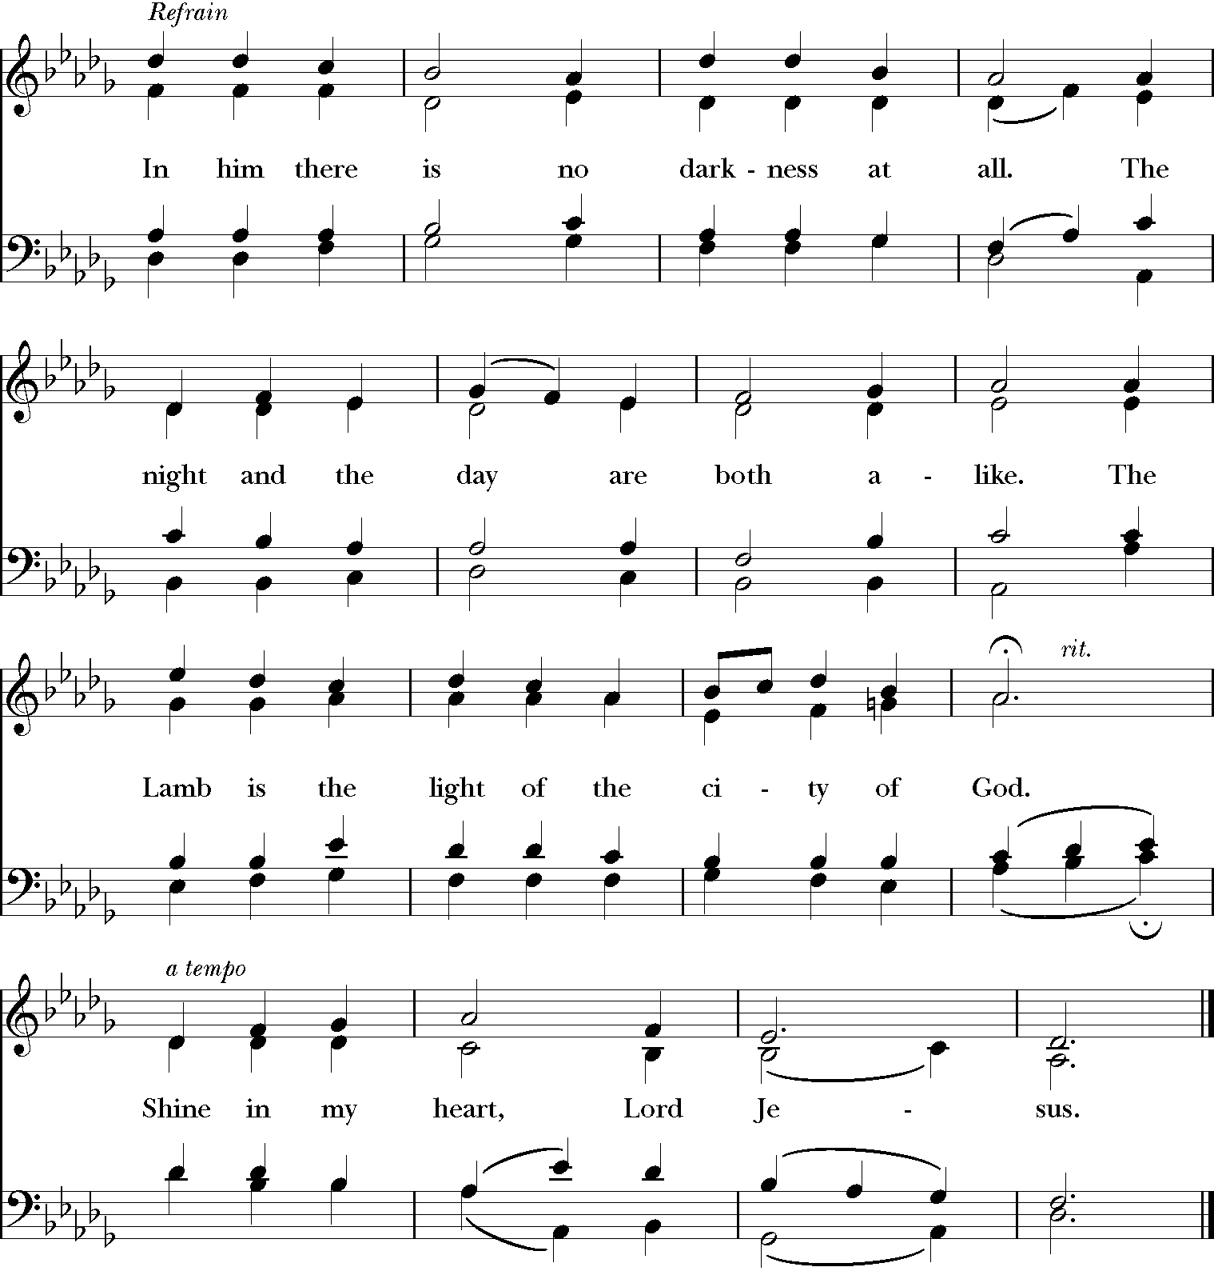

SCRIPTURE John 1:1-5
The Rev. Jane Miron: A reading from the Gospel of John.
In the beginning was the Word, and the Word was with God, and the Word was God. He was in the beginning with God. All things came into being through him, and without him not one thing came into being. What has come into being in him was life, and the life was the light of all people. The light shines in the darkness, and the darkness did not overcome it.

HOMILY The Rt. Rev. Audrey Scanlan

MUSICAL REFLECTION Abide with Me
arr. by Amy Tate Williams
Christyan Seay, tenor; William Wright, piano

PRAYERS OF THE PEOPLE
The Congregation is invited to place the names of those who have died in
the chat during the Prayers of the People.

The Rev. Jennifer Mattson: In peace, let us pray to the Lord.
Almighty God, who has knit us together in one communion and fellowship, in the mystical body of your Son, Jesus Christ our Lord: Grant, to your whole Church, in paradise and on earth, your light and your peace. Amen.

The Rev. Grant Ambrose: Grant to all who mourn the loss of loved ones
to COVID a sure confidence in your loving care, that, casting all their grief on
you, they may know the consolation of your love. Amen.

Rayelenn Casey: Help us, we pray, in the midst of things we
cannot understand, to believe and trust in the communion of saints, the
forgiveness of sins, and the resurrection to life everlasting. Amen.

The Rev. Gene Tucker: Guide those in authority over us, that they may
make wise decisions and act decisively to protect us and maintain the good
order of the societies and economies in which we live and work. Amen.

Anthony Alexander: Protect first responders and those who are
called professionally and vocationally to give of themselves so bravely and
selflessly to heal and care for us should we fall ill: our doctors and nurses,
social workers, health care providers and all who support them. Amen.

Canon Alexis Guszick: Stir our hearts to care for the vulnerable: the
elderly and the infirm, the poor and the homeless, those in prison, and for all who live alone. Amen.

The Very Rev. Amy Welin: Bless our teachers, students, staff and their
families as they navigate learning in new ways. Keep them safe and grant them the grace to persevere in uncertain times. Amen.

The Rev. Canon Chris Streeter: On this day, we offer our prayers for the
more than 500,000 victims of the COVID-19 pandemic, including:

Ed Bice  Joan Blackwell  Robert Carter  The Rev. Canon Stephen Casey  Shirley John  Dean Keeports  Larry Lloyd  Virginia Matthews | Mary E. Myers  Bessie Ritter  Donna Jane Rogers  Robert Russell  George Schneider  Mary Schneider  Robert Tayton Jr.  Alain Walker
Grant us grace to entrust our loved ones to your never-failing love; in that
kingdom where there is no death, neither sorrow nor crying, but fullness of
joy with all your saints in life everlasting. Amen.

THE LIGHTING OF CANDLES

You are invited to light a candle at this time, in remembrance of those whom we love, but see no longer. During the singing of the hymn, videos of those participating through our ZOOM webinar will be shared.

HYMN Jesus, Remember Me

THE LORD’S PRAYER
Bishop Scanlan invites the Congregation to join in the Lord’s Prayer.
Our Father, who art in heaven,
hallowed be thy Name,
thy kingdom come,
thy will be done,
on earth as it is in heaven.
Give us this day our daily bread.
And forgive us our trespasses,
as we forgive those
who trespass against us.
And lead us not into temptation,
but deliver us from evil.
For thine is the kingdom,
and the power, and the glory,
for ever and ever. Amen.

CLOSING PRAYER
Bishop Scanlan: Let us pray.
Loving God, we remember before you this day our brothers and sisters who have died from COVID. We thank you for giving them to us as family and friends, as neighbors and fellow citizens and companions along the way. Grant, O Lord, to all who are bereaved the spirit of faith and courage, that they may have strength to meet the days to come with steadfastness and patience; not sorrowing as those without hope, but in thankful remembrance of your great goodness, and in the joyful expectation of eternal life with those they love. And this we ask in the Name of Jesus Christ our Savior. Amen.

THE BLESSING The Rt. Rev. Audrey Scanlan

POSTLUDE MUSIC

