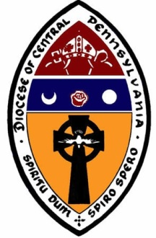
APPLICATION FOR Stevenson School for Ministry
VOCATIONAL MINISTRY & DISCERNMENT PROGRAM
The Episcopal Diocese of Central Pennsylvania

Section I: Personal Data

Name:
(Last) (First) (Middle/Maiden)

Home Address:
(Street, Apt #)

(City, State, Zip)

Home Phone: Cell Phone:

Preferred Email Address:

Date of Birth: Place of Birth:

Occupation:

Employer’s Name:

Employer’s Address:

Business Phone:

Spouse’s Name:

Spouse’s Date of Birth: Spouse’s Occupation:

Children’s Names and Ages:

Parish/Congregation you attend:

Congregation Address: Phone:

Priest’s Name: Cell:

Length of Time you have attended:
At the above congregation in Diocese of Central PA

Section II: Education

High School Diploma:

City/State School Year

Technical/Vocational/Special Education:

School/Type of Training Degree/Certification Year

Undergraduate/Graduate
(Give School, Major, Degree and Year - start with most recent):

Current and Previous Theological Education
(Give School, Major, Degree and Year - start with most recent):

Please describe any previous seminary study, or diocesan, parish, or extension programs. If you wish to submit previous study for consideration of transfer credit, an official transcript must be submitted.

Section III: Vocational and Personal Understanding of Ministry
Please answer the following questions on a separate sheet of paper:
- Briefly describe the ways you have served Christ in your congregation and daily life, and outcomes.
- Briefly describe the nature of your vocation as you now perceive it.
- What expectations do you have for your future ministry?
- How do you feel that ordination would help you live out your ministry more fully?

Section IV: Financial
Check Applicable Items:
- I have adequate financial resources.
- My parish will be helping with expenses
- May need financial assistance

Applicant’s Signature Date

Complete and Return to the Dean, Robyn Szoke-Coolidge rszoke@diocesecpa.org

